📘
User Guide (For Contributors)

1. Purpose
This guide explains how to upload monthly LIHEAP data using the provided Google Form.
Please follow these steps carefully to ensure your data is successfully received and processed.

2. Accessing the Upload Form
Open the LIHEAP Monthly Data Upload Form using the shared link.
https://forms.gle/iSZ6uHmsjiYNcqsz5
You will be asked a small number of required questions before uploading the file.

3. Project Confirmation

Question:
Is this data for the LIHEAP project?
- Select Yes if the file contains LIHEAP data
- Select No if it is not LIHEAP data
⚠️ If you select No, the form will end and no file will be uploaded.
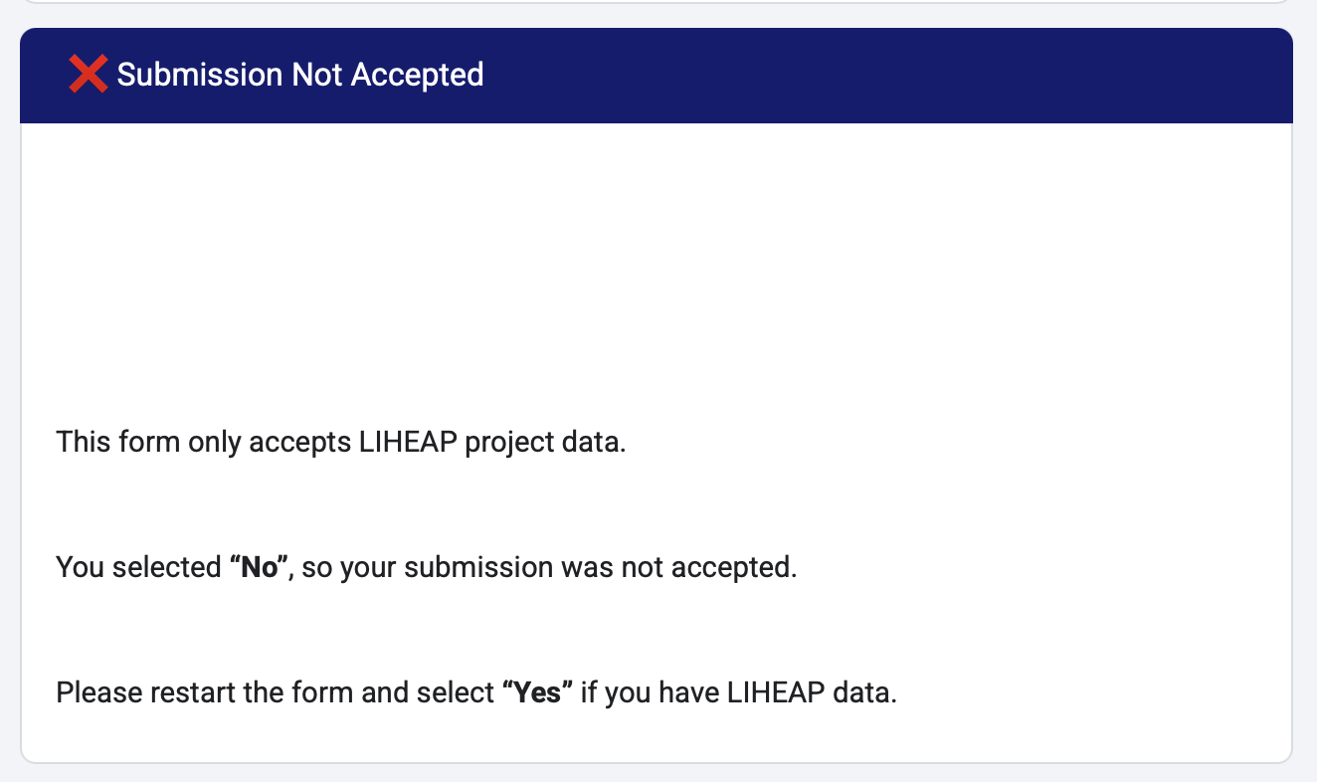

4. Enter Dataset Information
You will be asked to provide the following required information:

4.1 Data Year
Question:
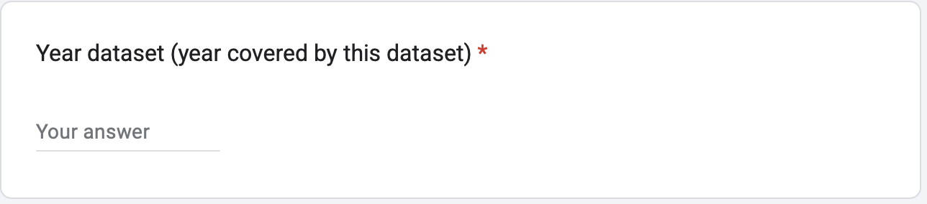
Year dataset (year covered by this dataset)
- Enter the year the data represents
- Format: YYYY
- Example: 2025

4.2 Data Month
Question:
Month dataset (month covered by this dataset)
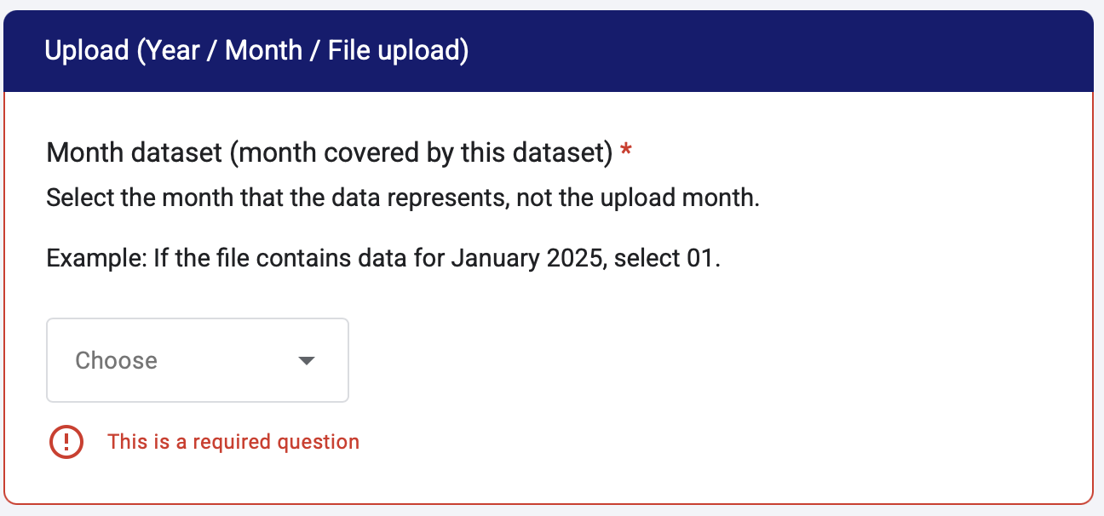
- Select the month the data represents
- Format: 01 – 12
- Example: 01 for January

Note: This refers to the month covered by the data, not the upload date.

4.3. Contributor Identification



Your name
- Enter your full name
- This information is used to:
  - Identify who submitted the dataset
  - Support follow-up in case of questions or corrections

5. Upload the File

File Upload Requirements
- File format: Excel (.xlsx)
- Number of files: 1
- File size limit: as specified in the form
You do not need to rename the file before uploading.

6. File Naming (Automatic)
After submission, the system will automatically rename the uploaded file using the following format:
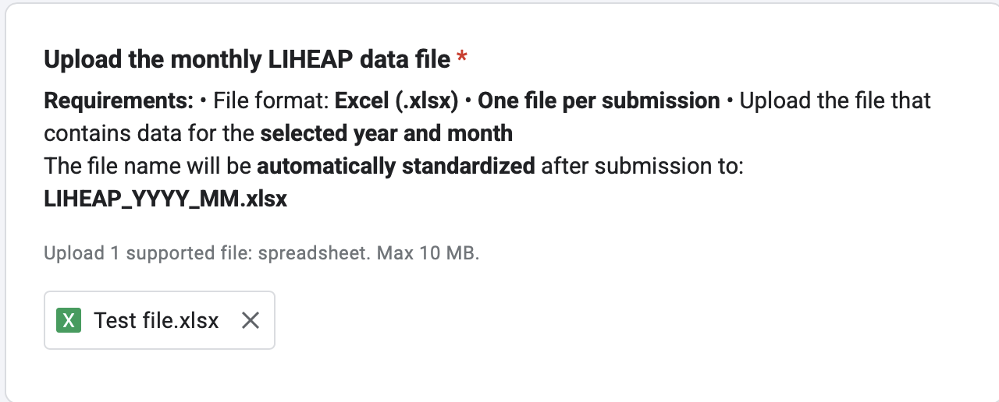
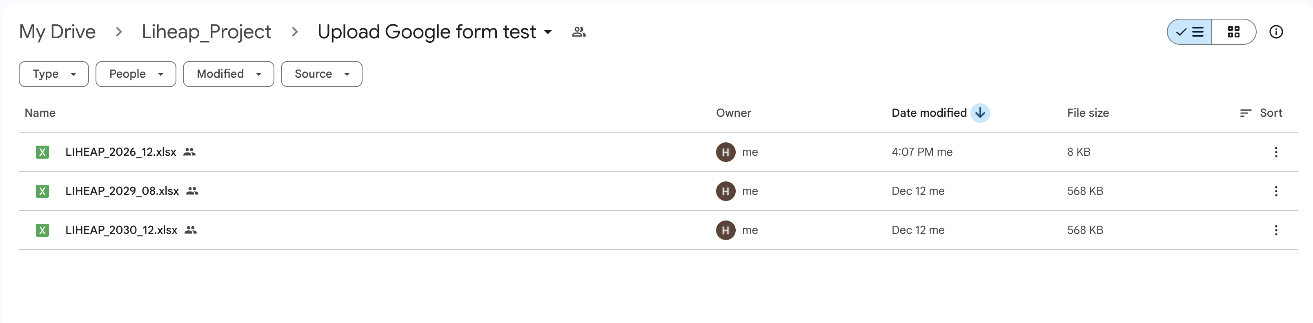
After you submit the form, the uploaded file is automatically renamed based on the Data year and Data month you selected.
For example, if you upload Test file.xlsx and choose Year = 2026 and Month = 12, the system renames it to:
LIHEAP_2026_12.xlsx
Then the file is automatically moved to the designated raw data folder in Google Drive.

7. Duplicate Submissions

If a file for the same year and month already exists:
- The existing file is not overwritten
- The new file is saved with a timestamp suffix

Example:
LIHEAP_2026_12__DUP_20251213-161638.xlsx
This allows corrected or updated datasets to be submitted safely.

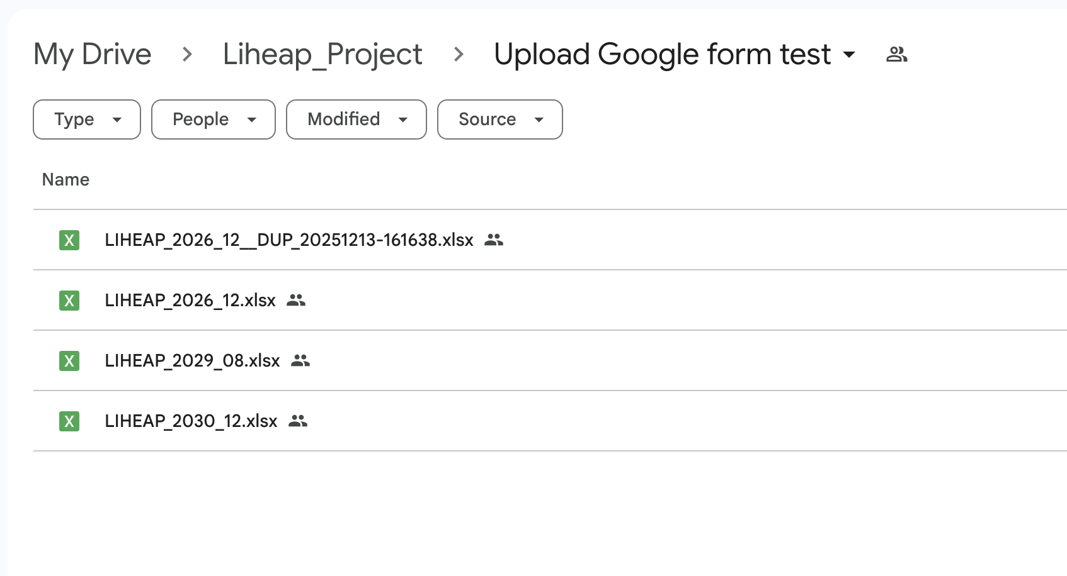

8. Submission Tracking
All submissions are automatically recorded in a Google Sheet, including:
- Contributor name
- Submission timestamp
- Dataset year
- Dataset month
- Uploaded file reference
- Final standardized file name
https://docs.google.com/spreadsheets/d/1gibfJFMO2r11z4bk4jMzJIyARpsaZ94Rge9WbmgHX94/edit?usp=sharing
This sheet is used to track received data and identify missing months.
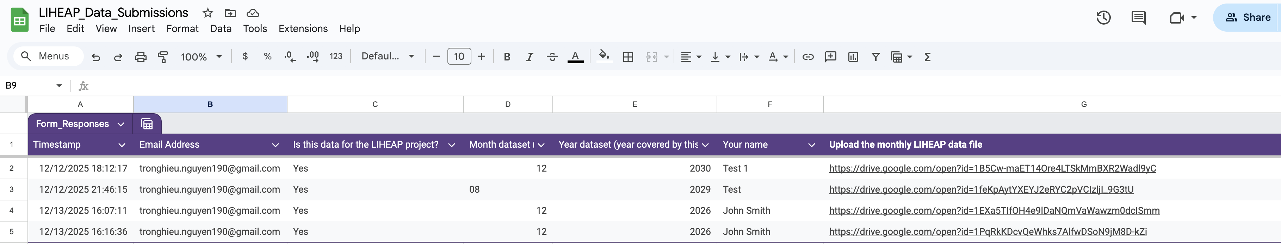

9. After Submission
Once the form is submitted:
- The file is stored in the project folder
- The file name is standardized automatically
- The submission is logged

No further action is required from the contributor.

